Session 2

Notes (also see PDFs)

* **Law of Large Numbers**: as you approach infinite samples, you should see the mathematical probability of outcomes reflected (ex. Rolling a dice 6 times will probably not reflect 1/6 probability for each number, but rolling it infinite times will).
* **Disjoined** or **Mutually Exclusive** values: outcomes that cannot simultaneously occur (ex. P(heads) and P(tails) are disjoined.
  + For **Disjoined** events, you can **sum the probabilities.** (This is one of the only cases where you can do this – most of the time, you multiply probability).
* More on **Disjoined** vs. **Non-Disjoined** (and the **General Addition Rule**)

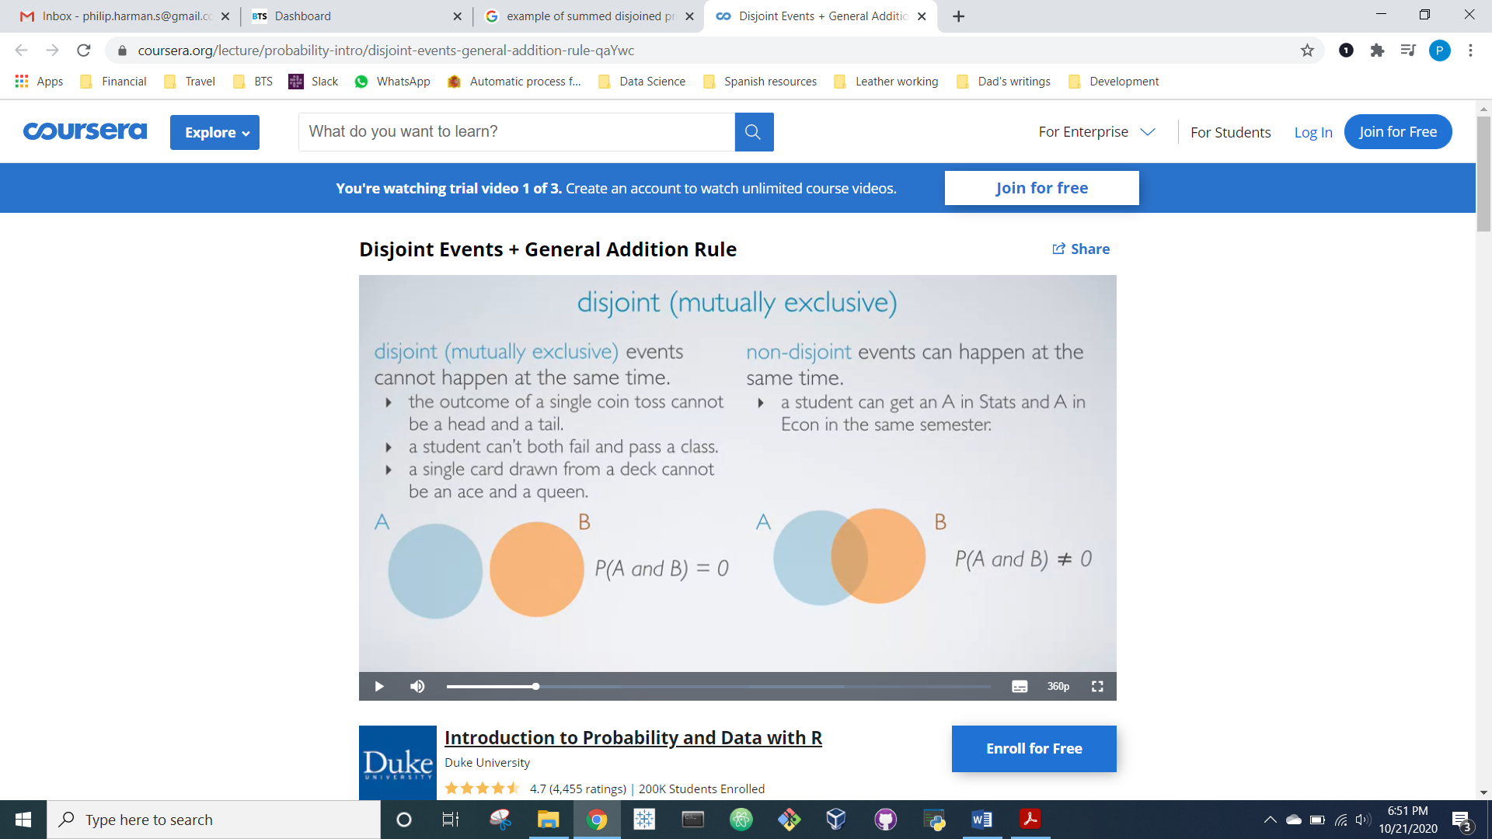

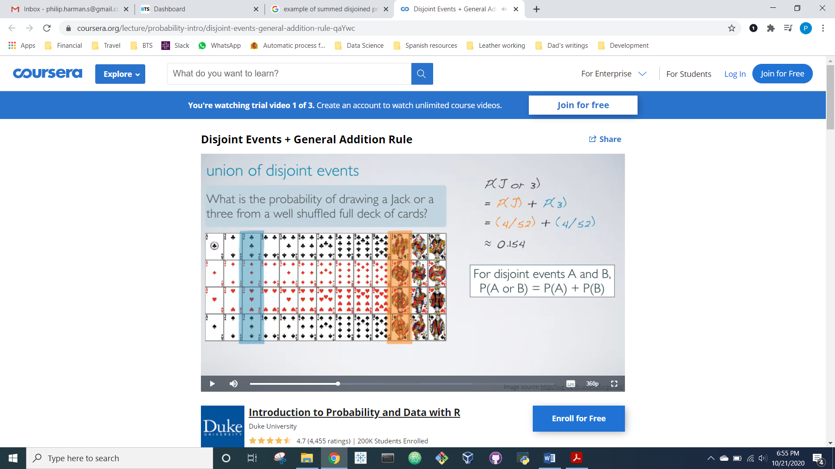



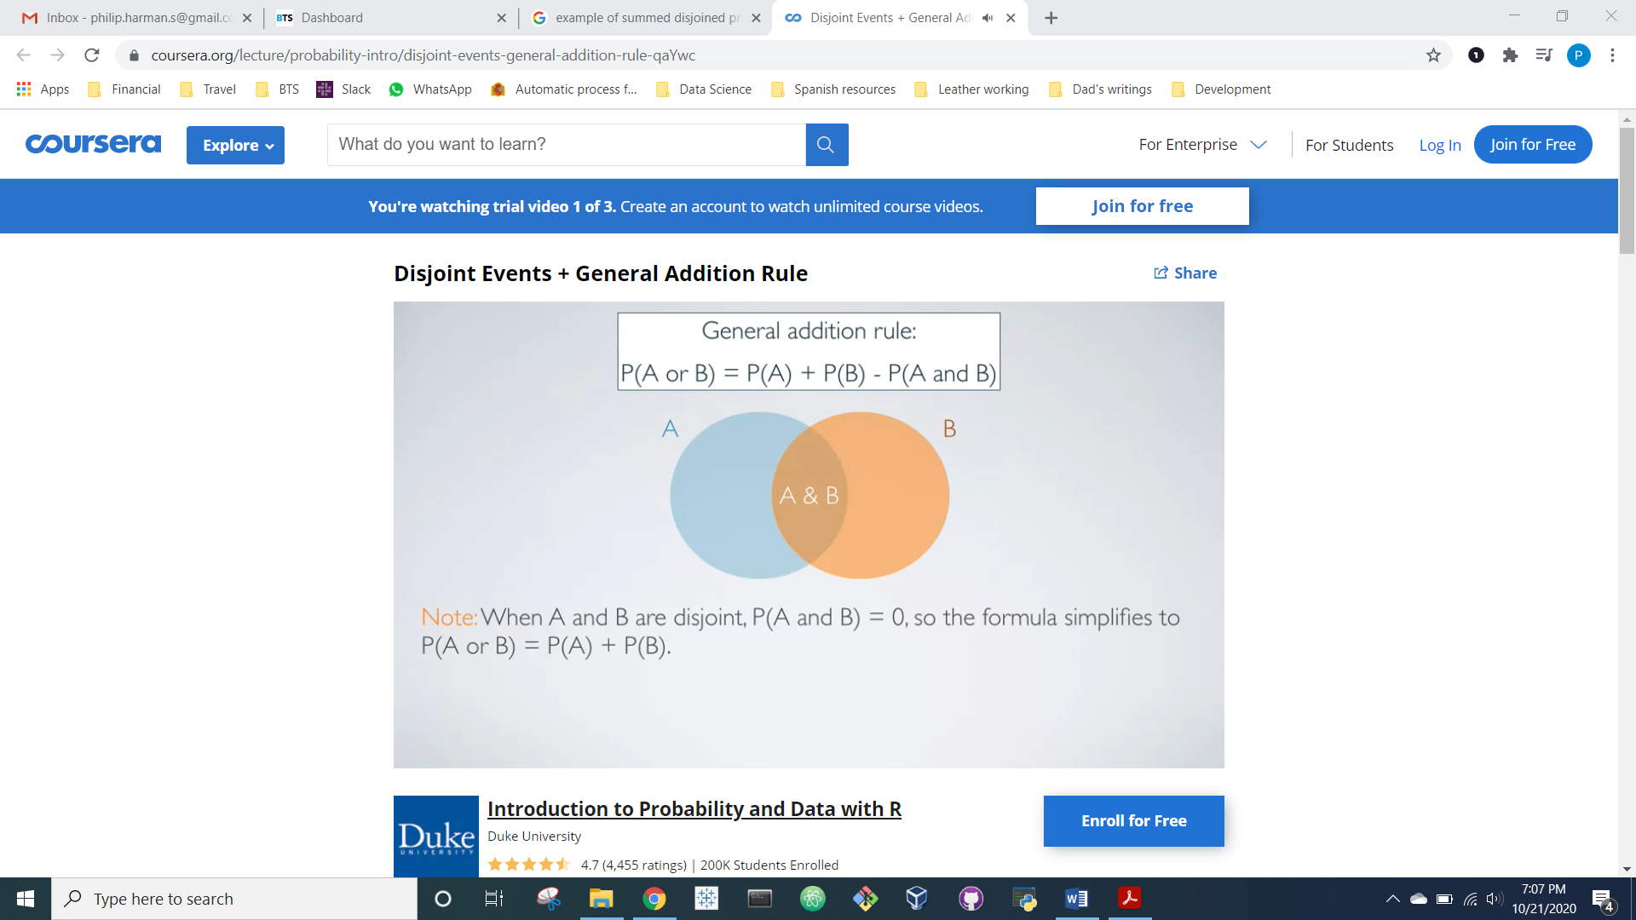



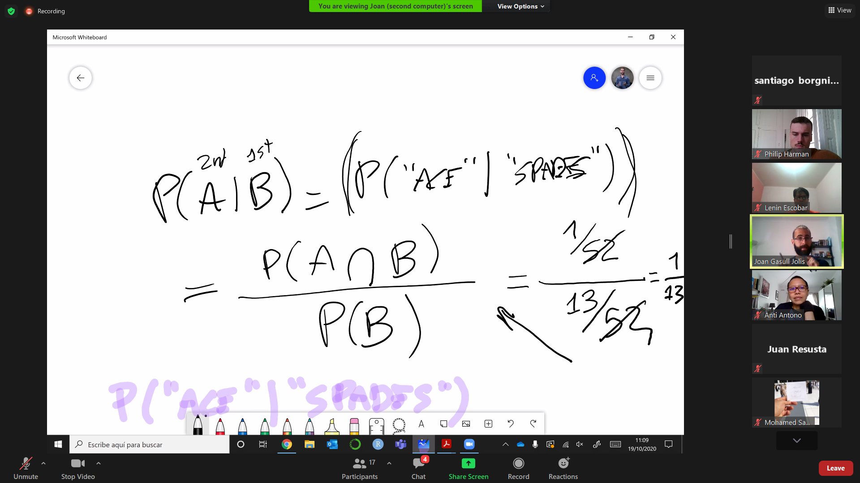

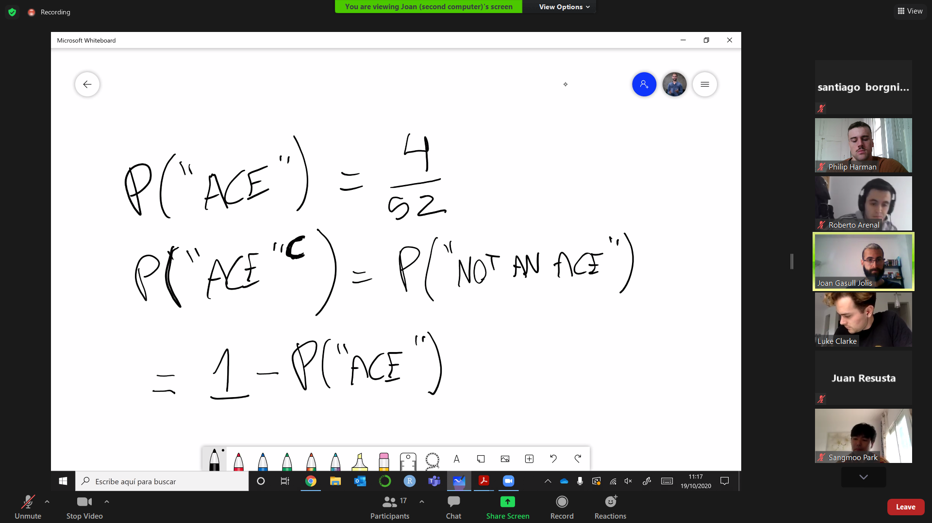

* **Notation and equations summarized:**
  + P(A U B): Probability of A OR B occurring (aka the Union)
    - P(A U B) = P(A) + P(B) - P(A **∩** B)
  + P(A **∩** B): Probability of A AND B occurring (aka the Intersection)
    - P(A **∩** B) = see Bayes Theorem
  + P(A|B): Probability of A occurring GIVEN that B already occurred. Example: P(Ace|Spades) = probability of drawing an Ace of Spades given that we’ve already selecting among Spades
    - P(A|B) = see Bayes Theorem
* **Bayes Theorem:**

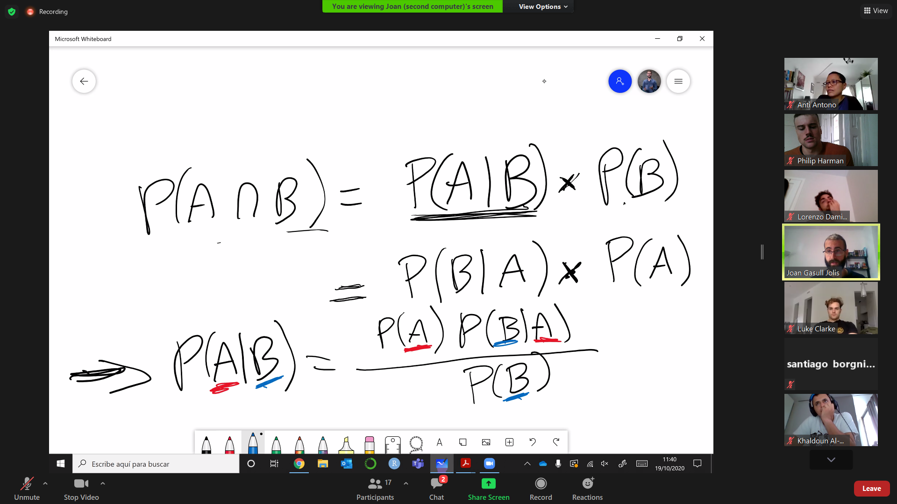

* **Some examples with multiple possible outcomes:**

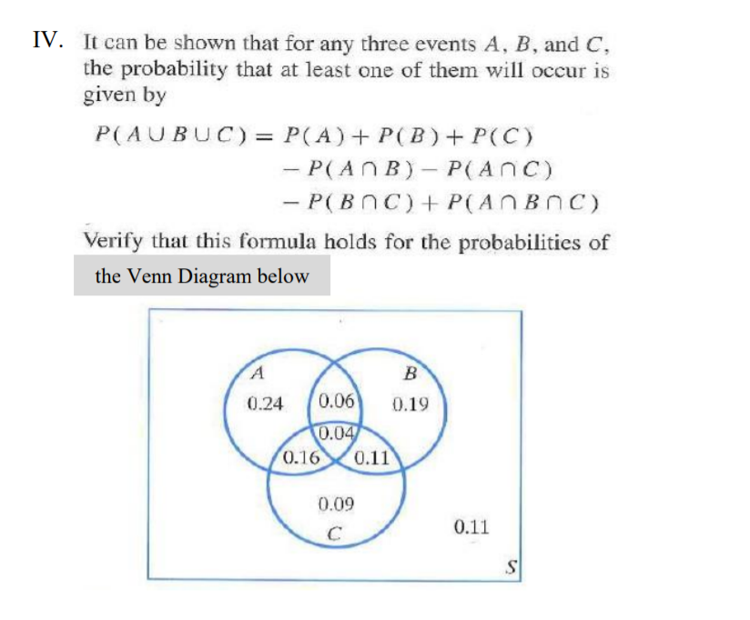

* **Probability Density Function**: the *relative likelihood* that a random value selected from a given population would equal a sample value (Note: relative likelihood is specified because absolute likelihood for continuous variables is 0)

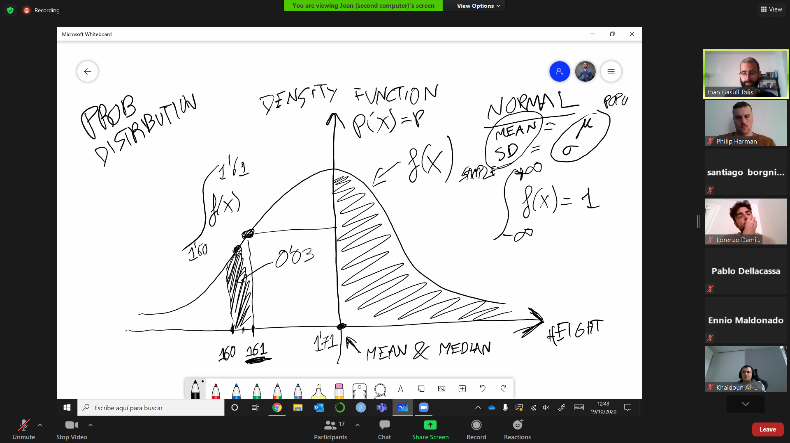

* **Cumulative Density Function**: The probably that given the distribution function of X, what is the probability the a randomly selected value will be <= x? (ex. A norm distribution where mean = 5. CDF of x=5 is p=0.50). In other words, this is the integral of the **Probability Density Function** for a given distribution.

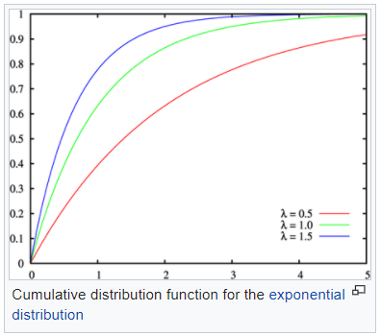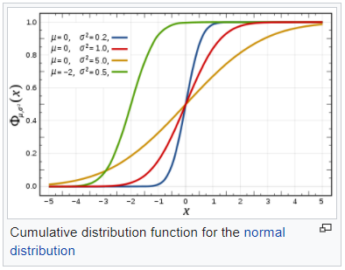

* **Normal Distribution** depends on two parameters: Mean and Standard deviation

Session 4

* **Inference** is always talking the **population (**we use the sample to infer about the larger group)
* **Helpful tip for notation:** if it’s a **Greek** letter, it’s about the **population**

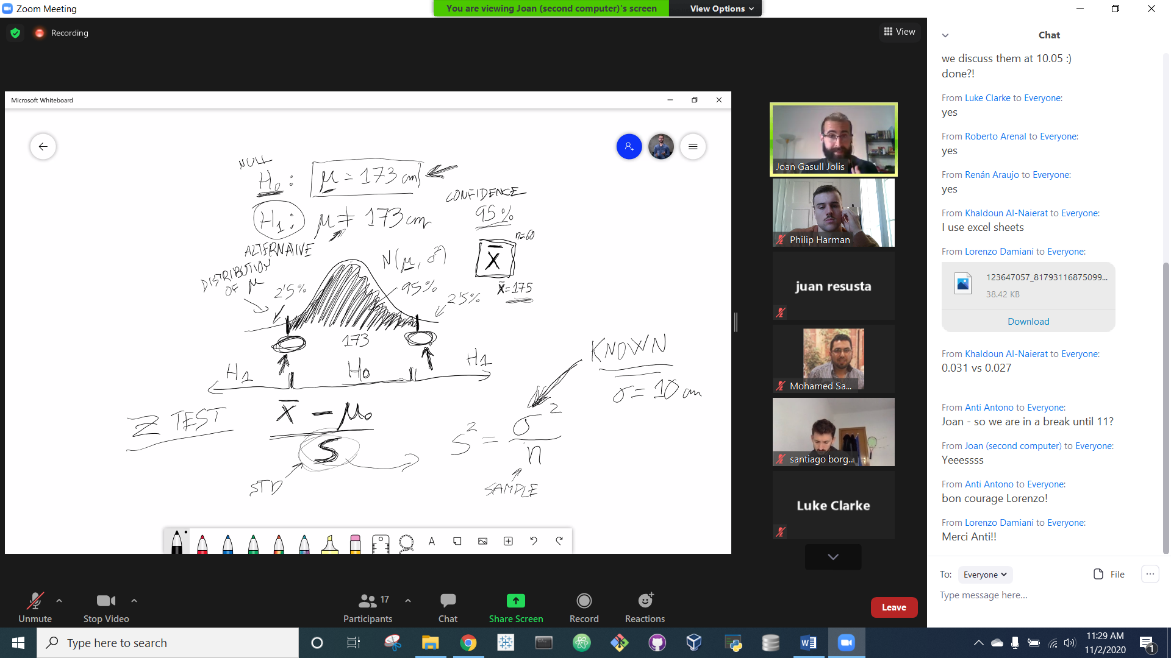

* **Z Test:** for testing the mean of a normalized Gaussian distribution.
  + Population standard deviation are sometimes known, but sometimes you have to use the std. dev. Of the sample.
  + 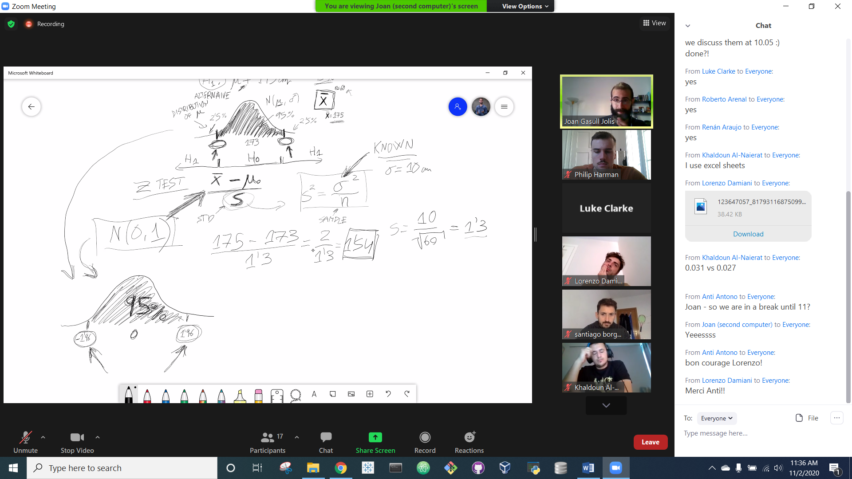The +/- 1.96 values of Z represent the 95% confidence interval of a N(0,1) distribution (this relates to the 68/95/99 rule)
* **P Value:** The probability of…
  + If P < Alpha (significance): H1 , reject H0
  + If P > Alpha (significance): H0, reject H1
  + Can be found using the Z-score in a table

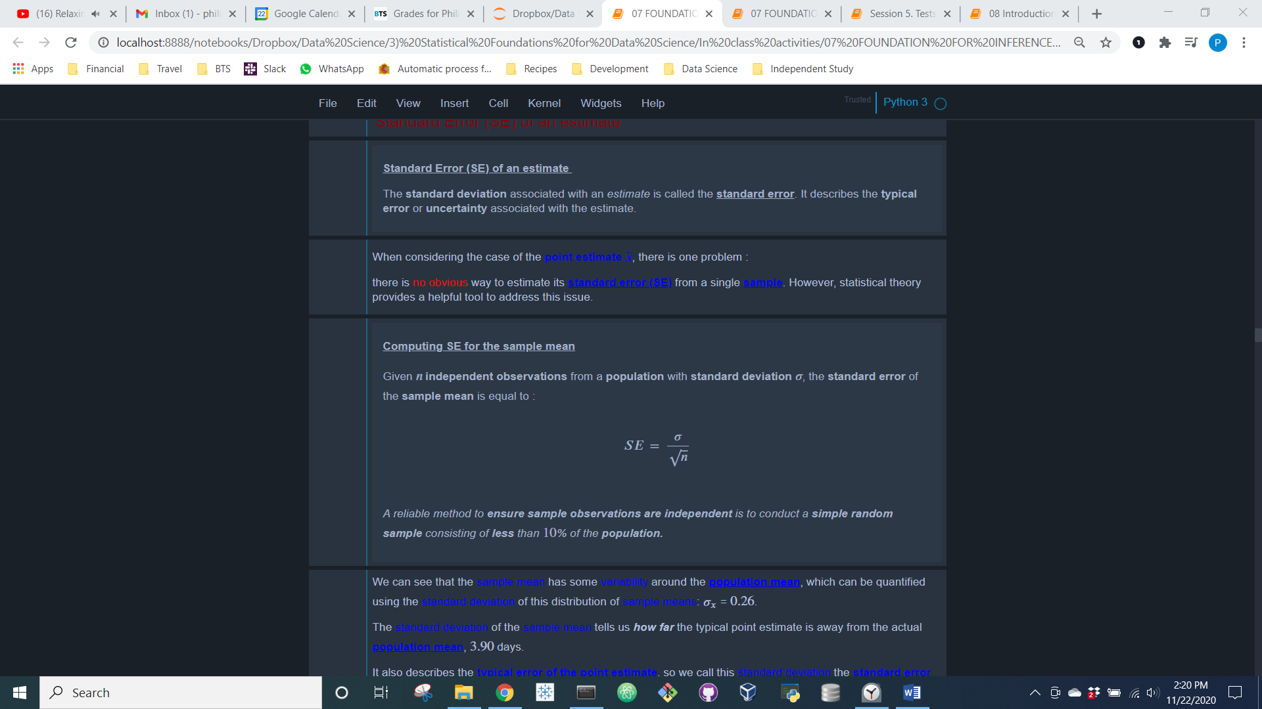

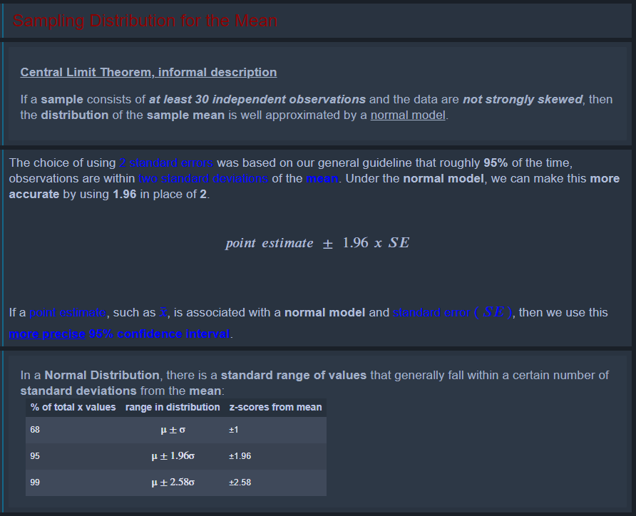

**Conditions for 𝑥-Bar being nearly normal and 𝑆𝐸 being accurate**

Important conditions to help ensure the sampling distribution of 𝑥¯ is nearly normal and the estimate of 𝑆𝐸 sufficiently accurate:

* The sample observations are independent.
* The sample size is large: 𝑛 ≥ 30 is a good rule of thumb.
* The population distribution is not strongly skewed. This condition can be difficult to evaluate, so just use your best judgement.

Additionally, the larger the sample size, the more tolerant we can be with the sample’s skew.

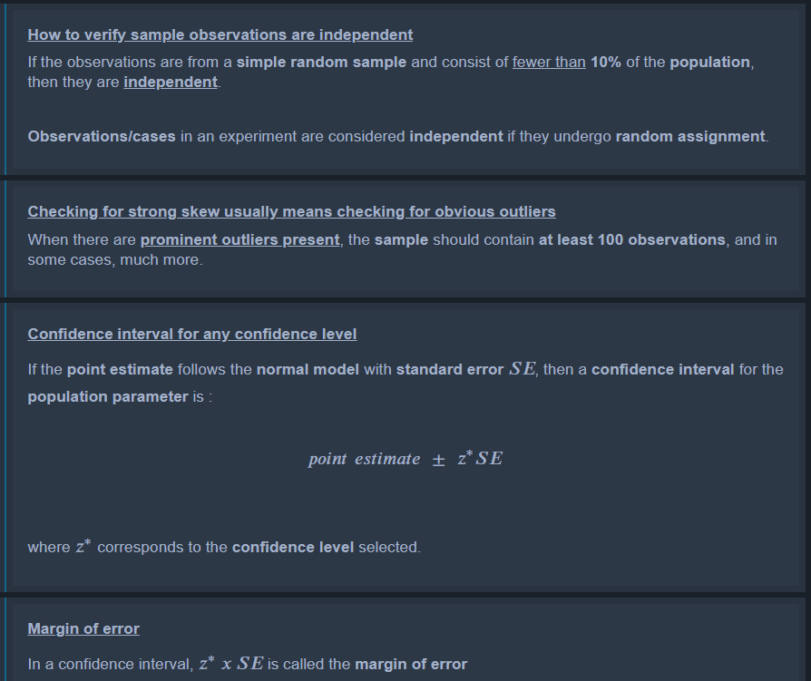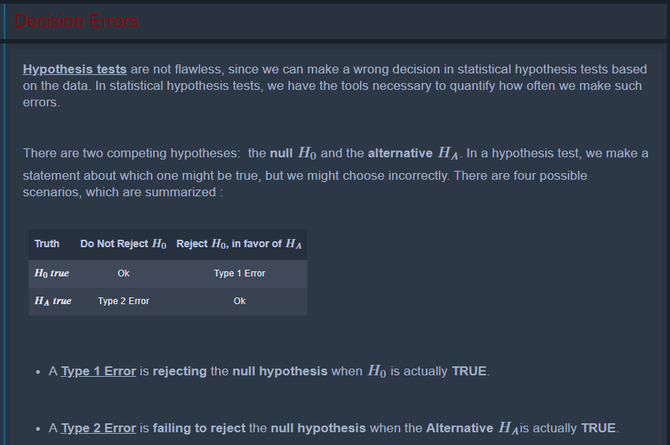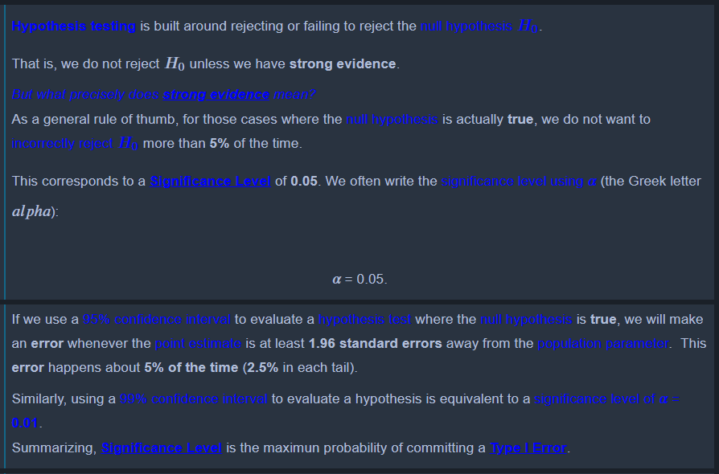

**Note on confidence, significance, and Type 1 Error:**

* Suppose confidence = 95%
* Significance = a = 0.05
* Therefore: probability of Type 1 Error = 5%

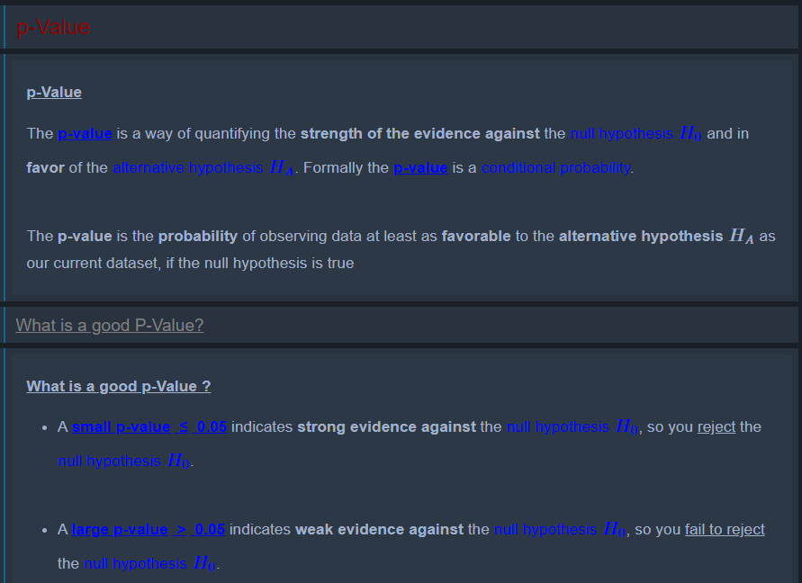

**Note on testing:** Switching a two-sided to one-sided test after observing the data can inflate the Type 1 error rate.

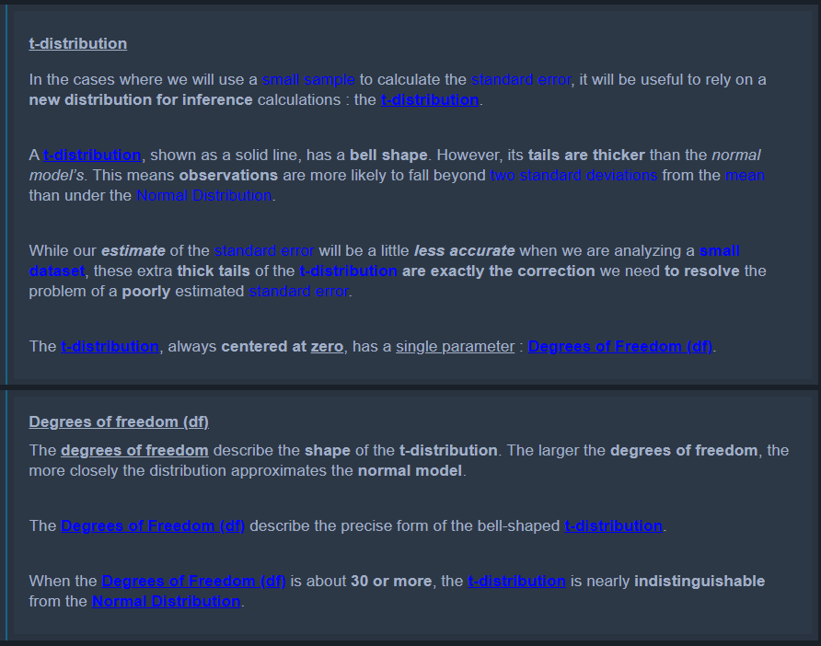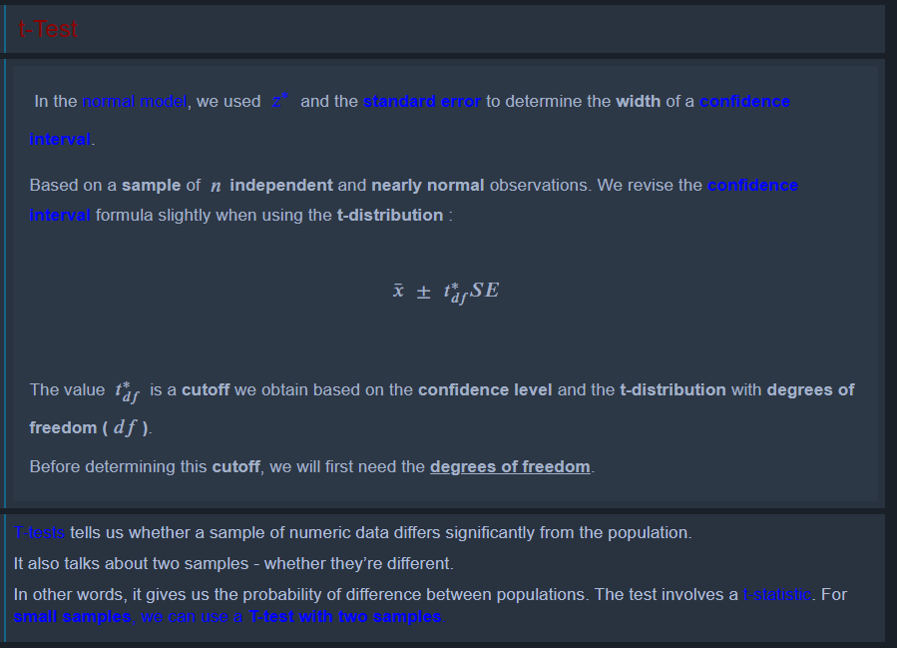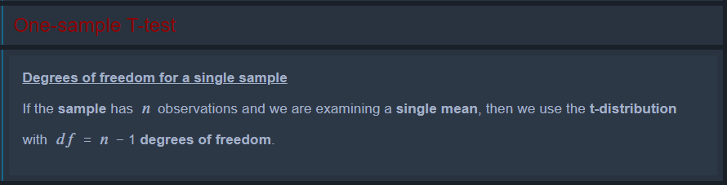

Paired T-Test

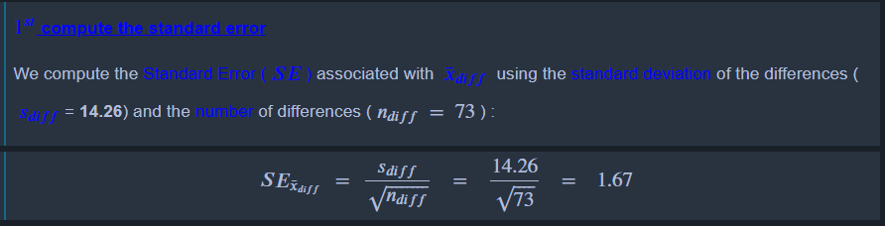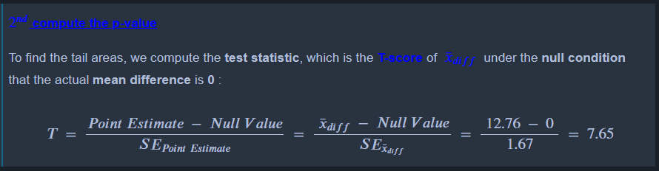

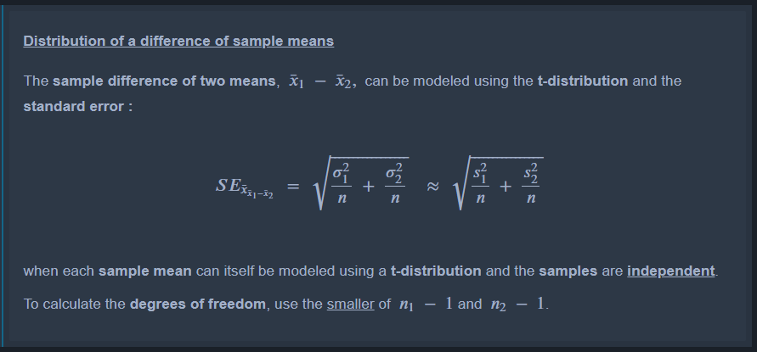

Session 5

* **T-Test:** Preferable to Z test when sample sizes are small
  + Purpose: to test if the means between two groups are consistently different
  + General idea:
    - T = (Variance between groups) / (Variance within groups)
      * Consequently: high variance within groups makes it harder to detect differences
    - BIG T = the groups are more different
    - SMALL T = the groups are more similar
  + P-value = probability that the pattern produced could be produced by random data (statistically significant is p = 0.05, i.e. 5% chance there is no real difference)
  + Larger sample size (for the same T score) means lower P-value (i.e. more significant results)
  + More degrees of freedom = distribution looks more like a Z-test
  + Three types of T-tests:
    - Independent samples: Test the means of two different groups
    - Paired samples: Test the difference mean difference between each group pair-wise
    - One sample: There’s only one group, and we want to test if it differs from a set value (like the mean IQ of one classroom vs. the mean IQ of the whole populace)
  + Parameters of T-Test:
    - DF = N-1
    - Sample mean(s)
* **T-Test 2 Populations:** Ex. Avg. height of men vs. women

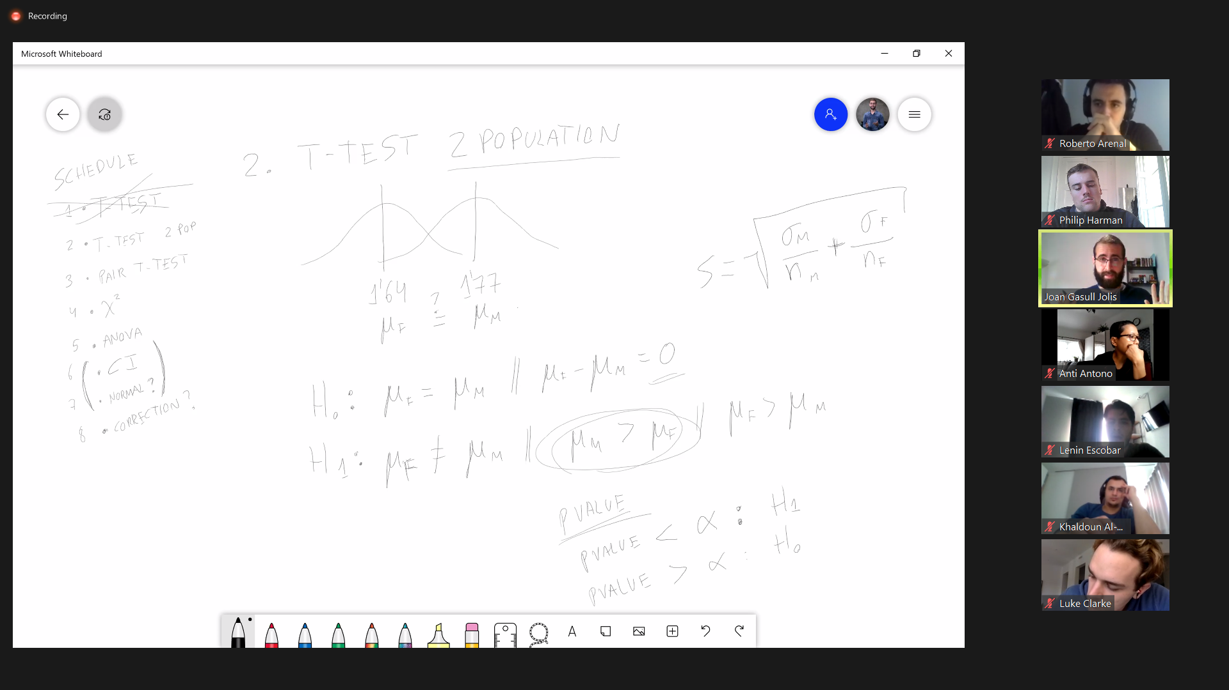

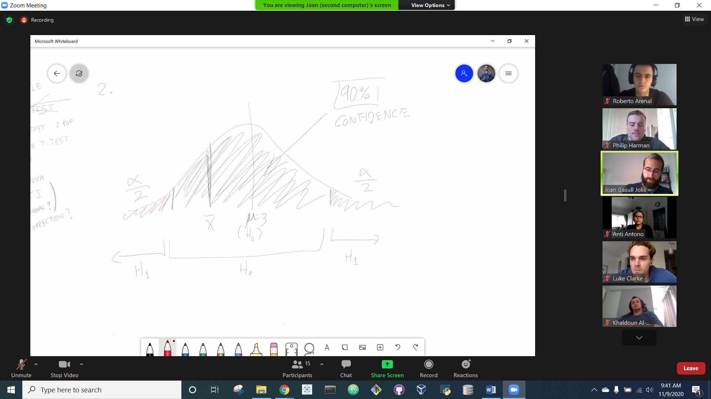

* **Pair T-Test:**

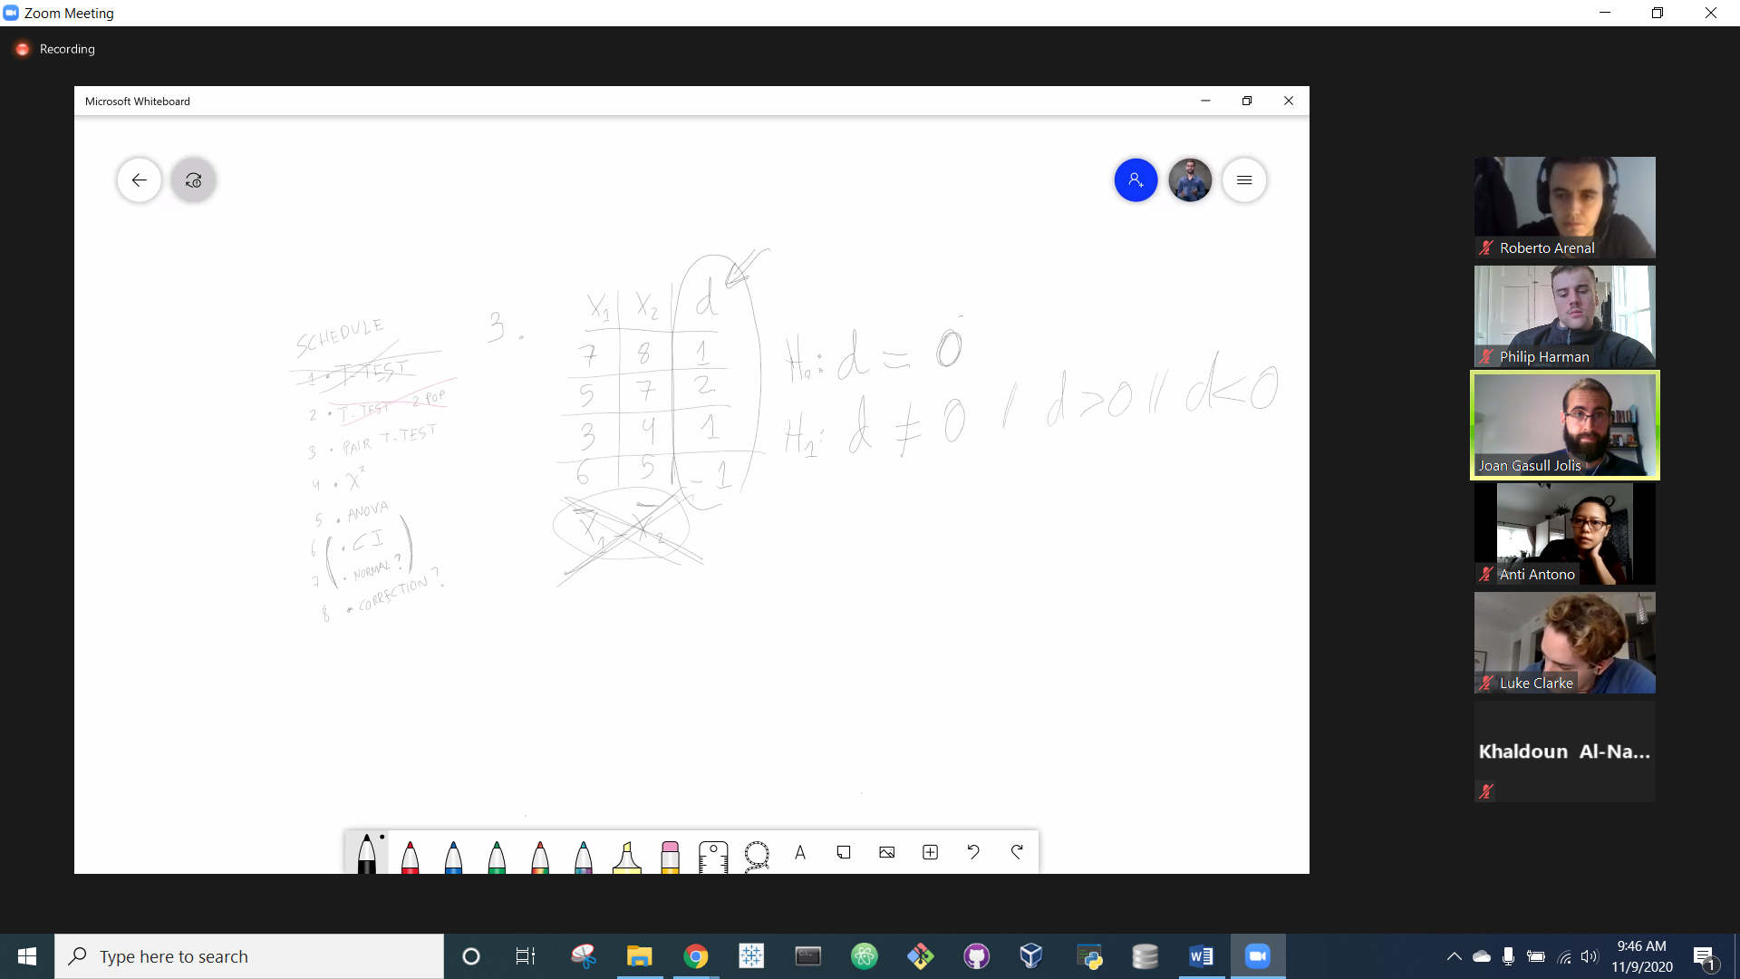

* + D = difference between each pair of values, then regular T-test is performed on the D values (rather than an aggregate mean test for X1/X2)
  + Ex. T-test for the start + end test scores for *each individual student* at the start and end of a course.

**Anova – Analysis of Variance (Comparing Means across groups)**

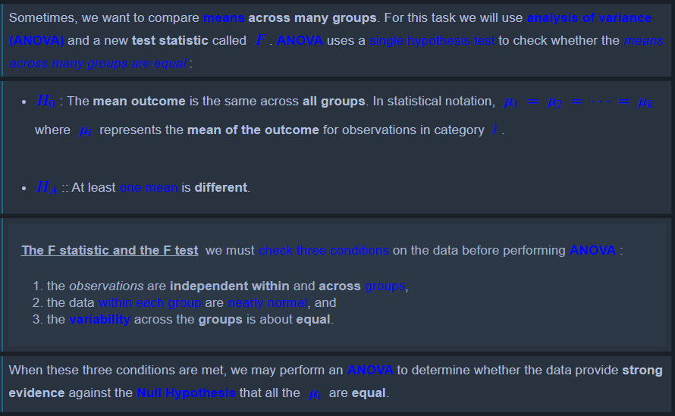

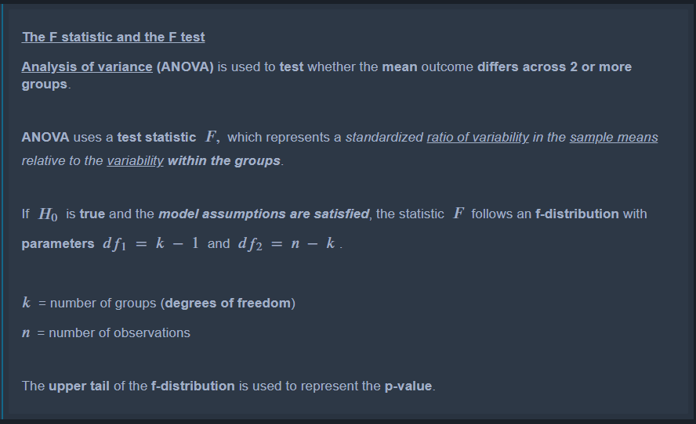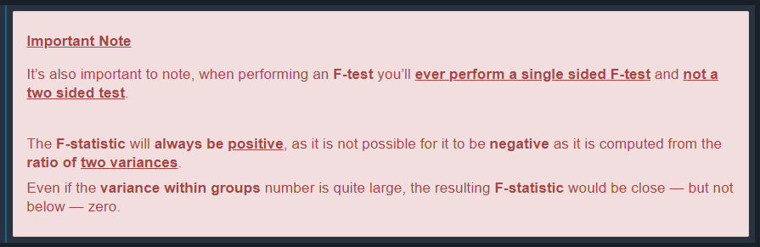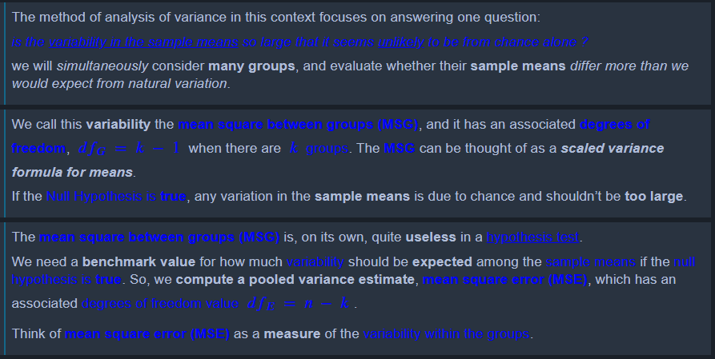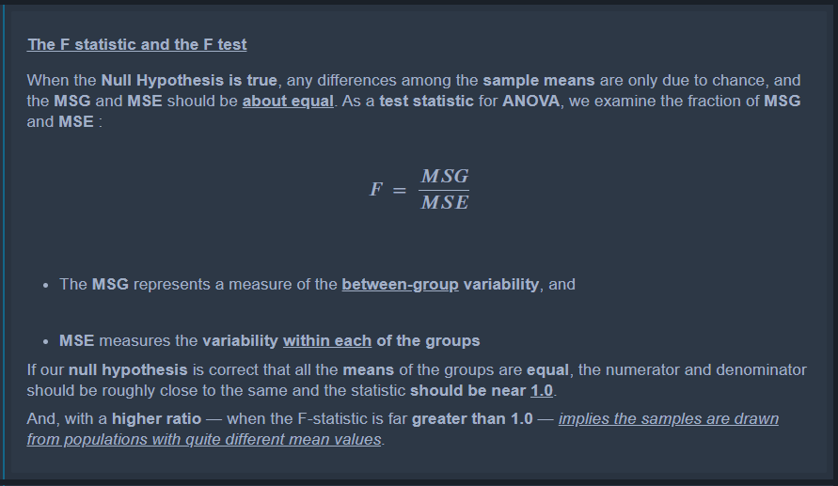

* **Chi Squared Test:** For testing if two variables are independent/dependent
  + Example: are on-time arrival/departures for airplanes interdependent?

Session 6

**Bootstrapping:** A method when information about the population (i.e. Mu and Sigma) are not readily available. Instead, a large sample of the population is taken, THEN this sample is sampled (WITH replacement). In short, **Bootstrapping** is just sampling with replacement to approximate the parameters of the population.

**Sibilare Presentation:** Social media listening company. Tracks social media activity + sentiment related to brands. Speaker: Adrian Becerra

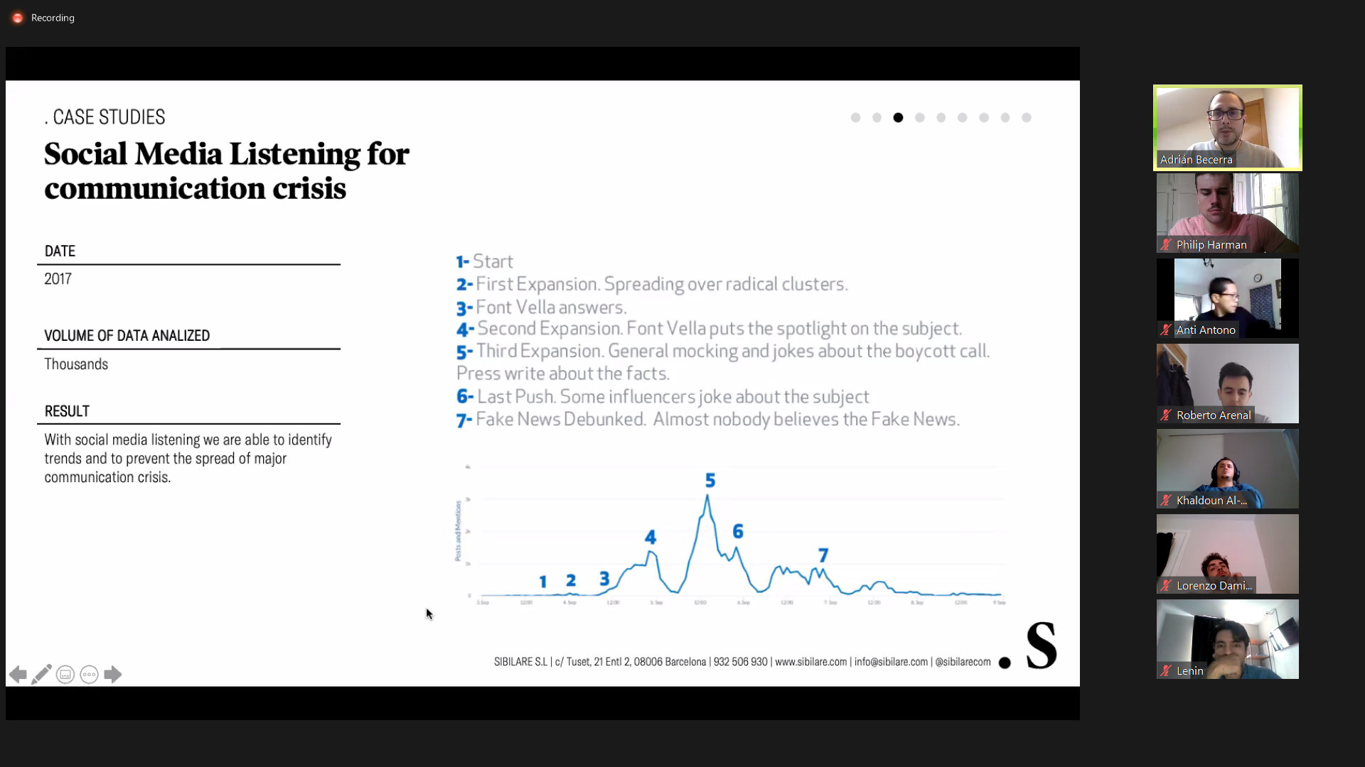



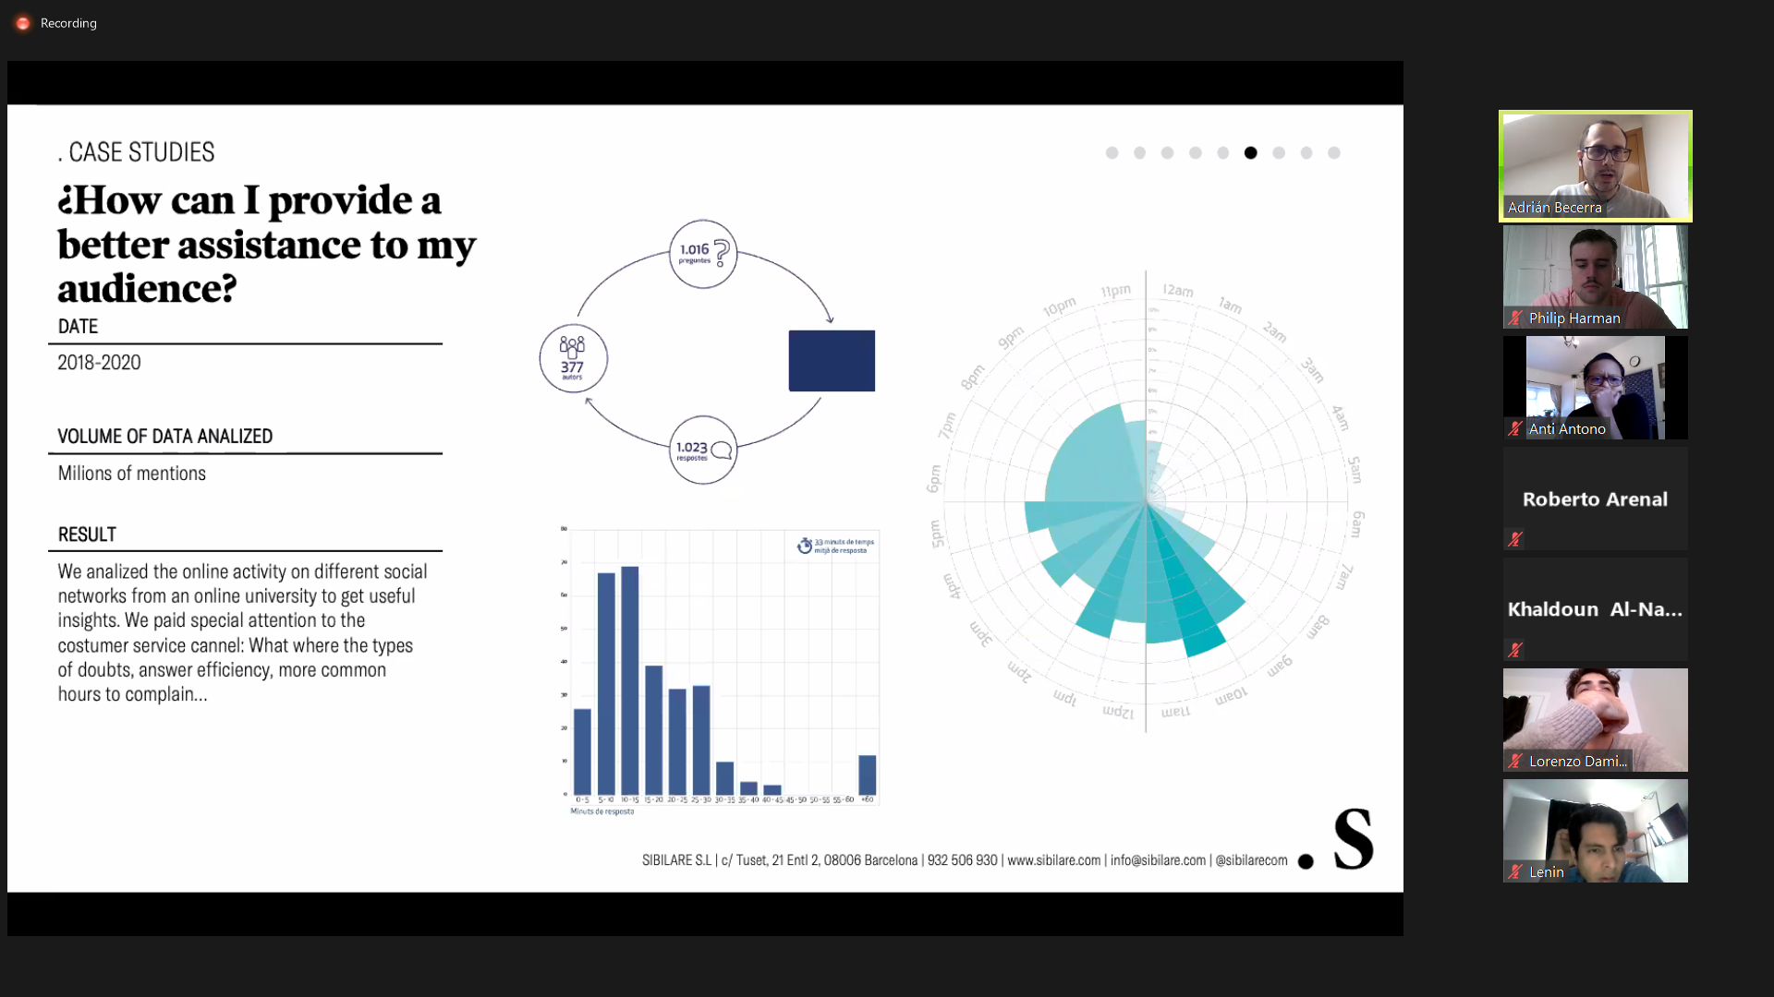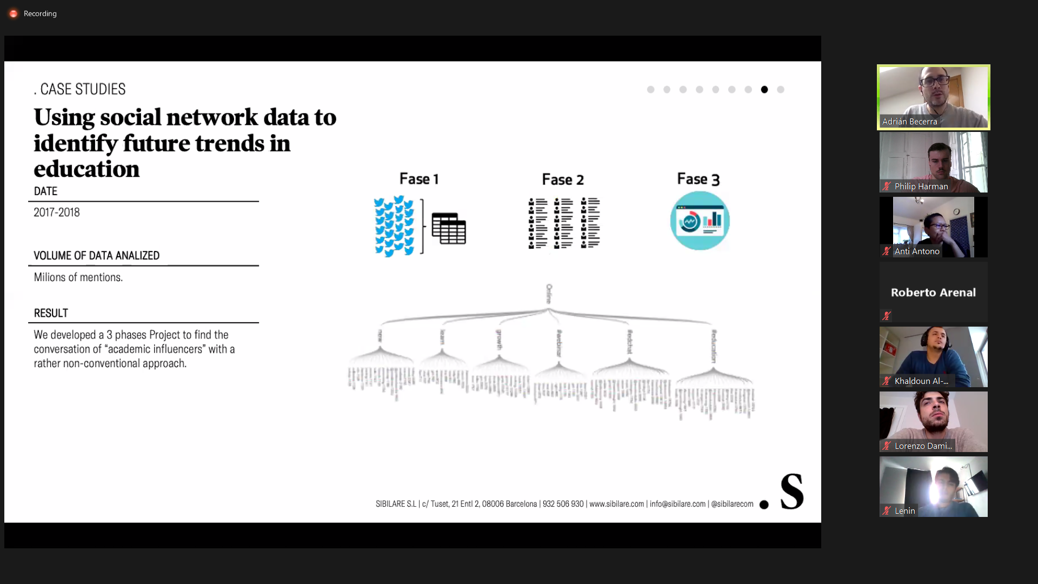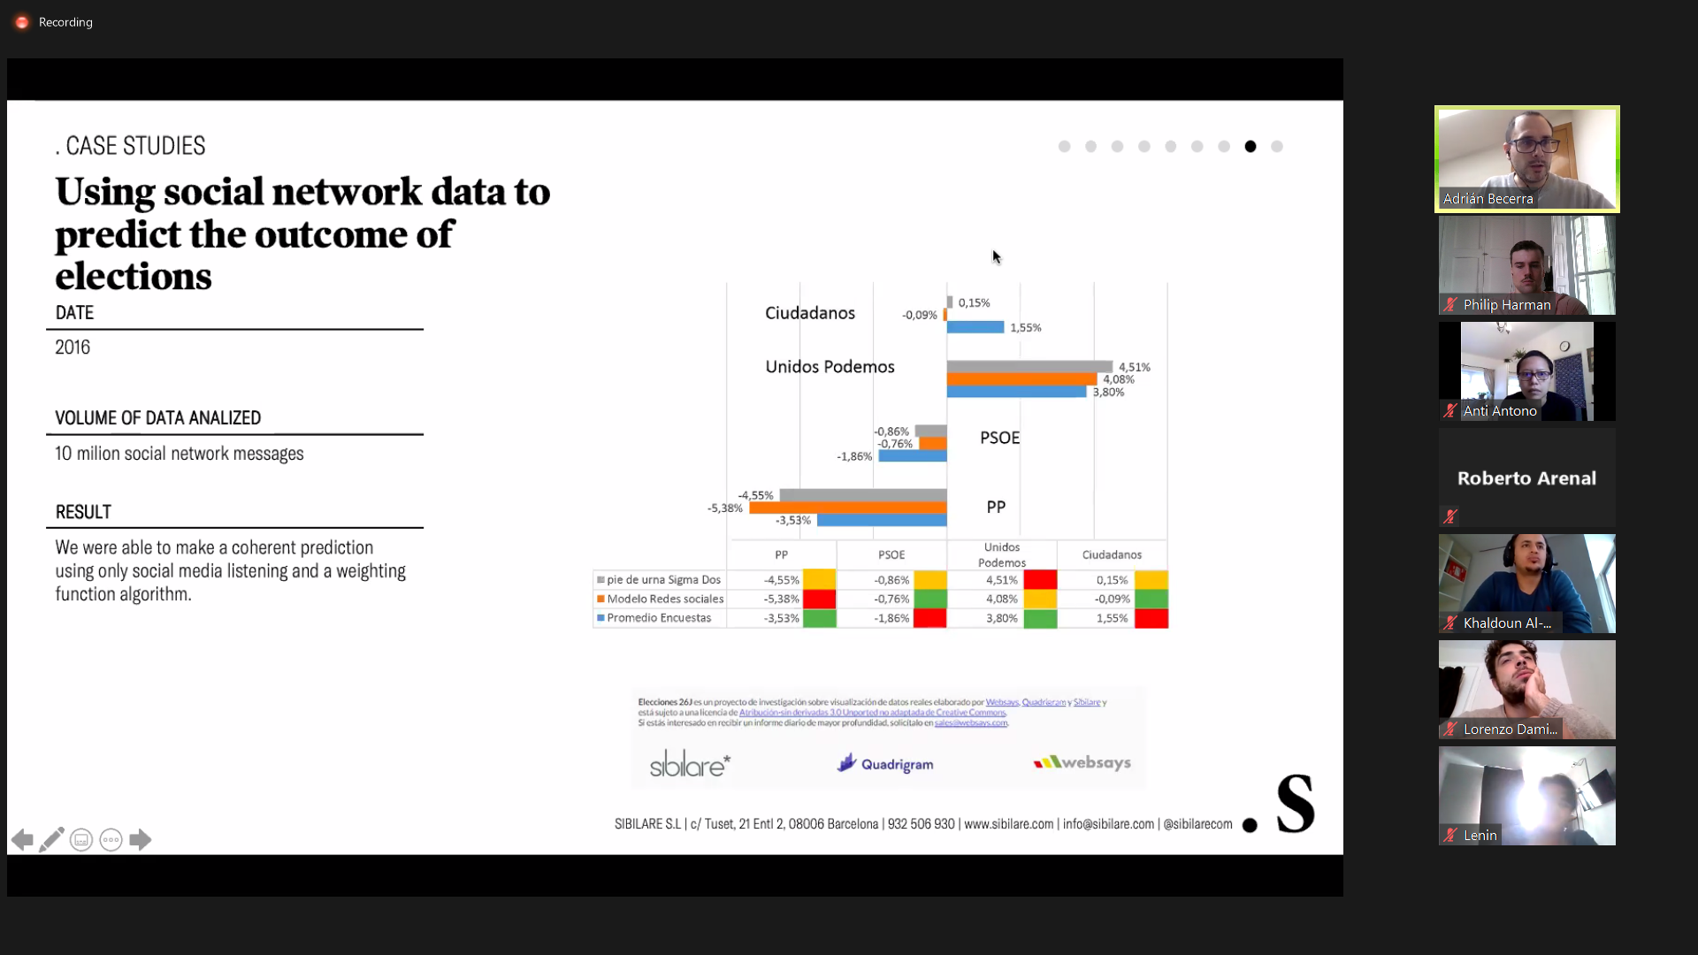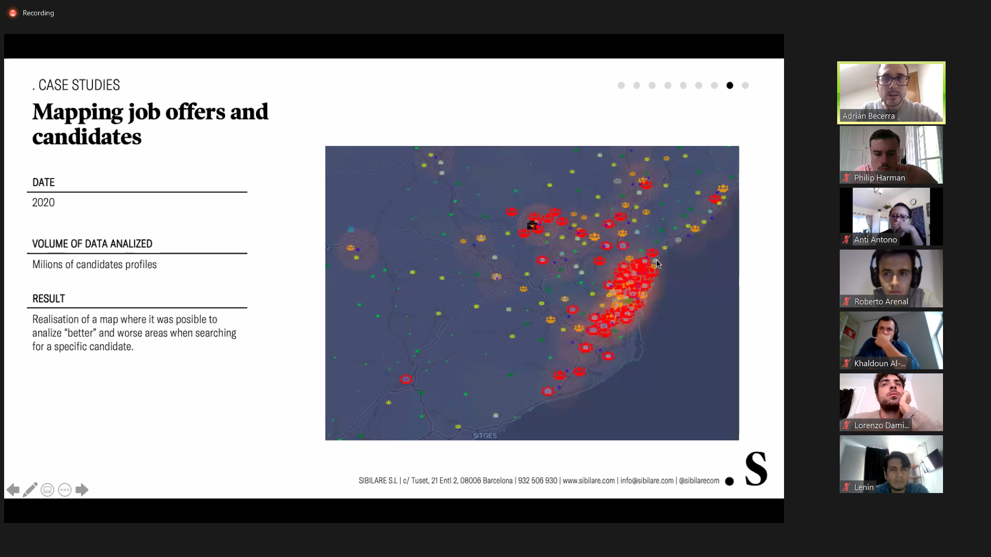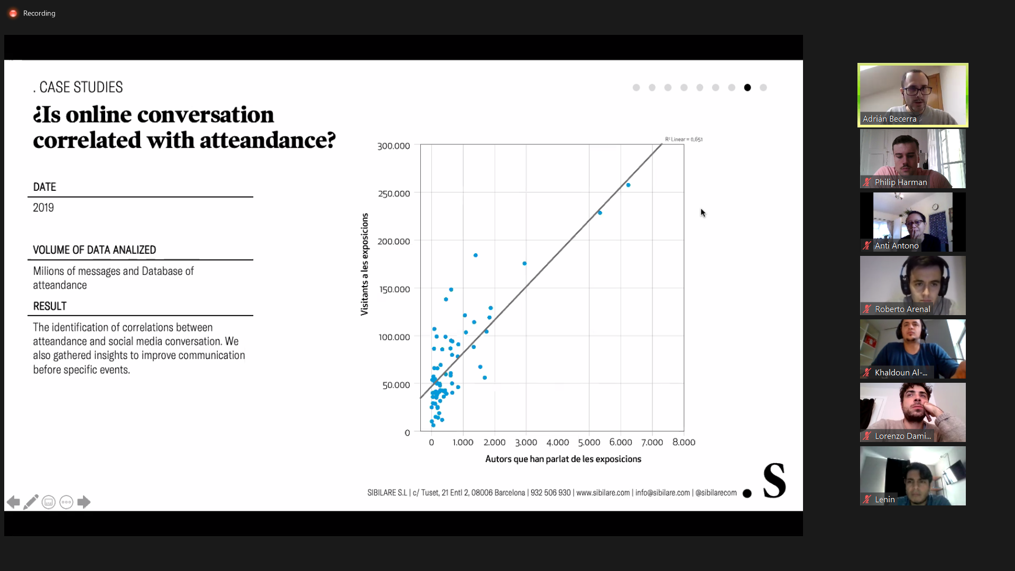

**Further exploration:** How might we better predict if an account (or each individual post) is sarcastic or serious praise/criticism? And how can we measure the impact of that? (Ex. A sarcastic meme criticizing Joe Biden, when in fact the creator supports Biden). Would have to take into account the cultural humor, too – ex. Young Americans tend to be pretty sarcastic, but perhaps a different demographic in a different country would be less so.